TEST 1

NAME : ARUNDHATHI

REGISTER NO: 192121008

DATE : 12/09/2023

1.SWAPPING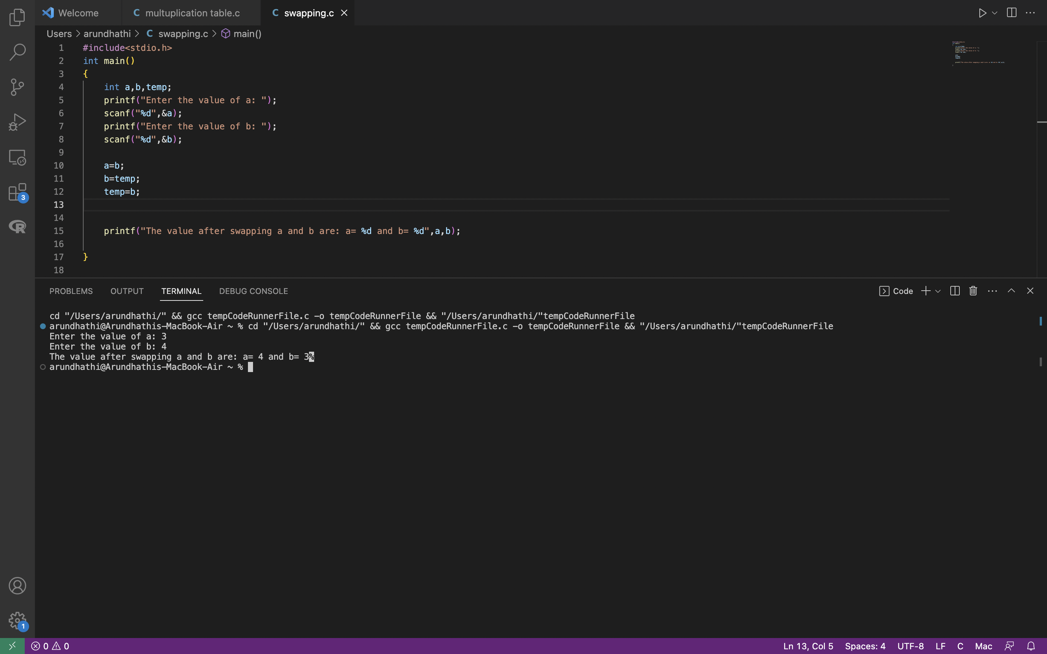

2.MULTIPLIC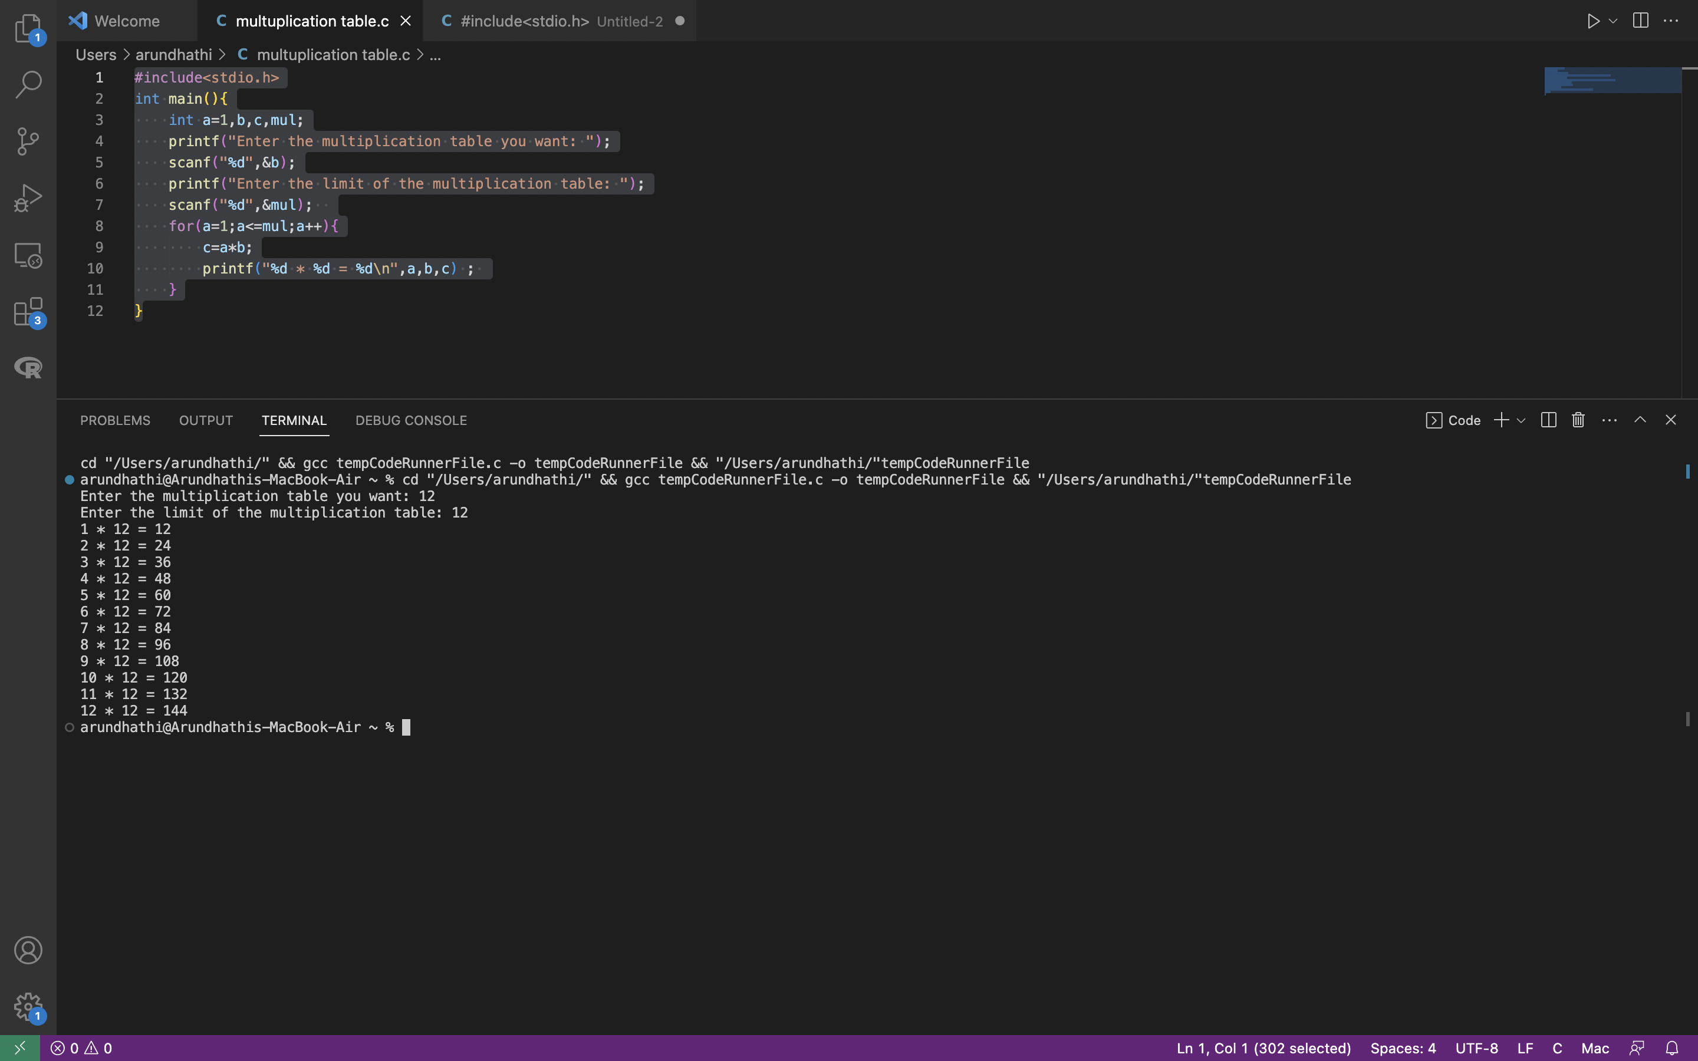ATION TABLE